**Linear Motion Revision**

1. A squash player hits the ball at a speed of 35.0 m s-1 at an angle of 30.0° to the side wall of the court. The ball rebounds at 120° to the original direction at a speed of 27.5 m s-1. What is its change in velocity? (Hint: use a diagram.)
2. Bernard Tomić celebrates a victory by climbing into the crowd and smashing a tennis ball vertically upwards. The 57.3 g ball is hit from a position 2.75 m above the ground with an initial velocity of 55.1 m s-1 upwards.
   1. Calculate the time the ball takes to reach the ground.
   2. Calculate the velocity of the ball after 5.10 s.
   3. Calculate the distance that the ball travels to reach the ground.
   4. Calculate the mechanical energy of the ball whilst in flight.
   5. The tennis racquet is in contact with the ball for 0.312 s. Calculate the impulsive force on the ball.
3. A keen bushwalker went for an extended hike as shown by the following graph.

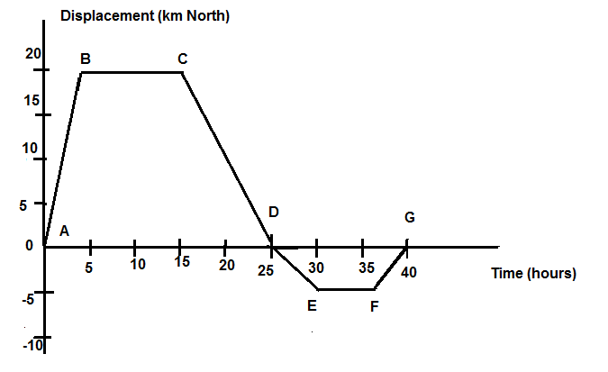

Use the graph to determine the following information:

* 1. How far did the hiker walk?
  2. Calculate the bushwalker’s velocity (km h-1) in the following segments:
     1. AB
     2. EF
     3. AG
     4. DE
  3. Draw a velocity-time graph for the hiker’s journey.

|  |
| --- |
|  |
|  |

* 1. For how long was the walker stationary?

1. Conall is sailing a boat North at 5.50 m s-1 when he enters a current travelling East at 1.50 m s-1. Calculate Conall’s resultant velocity (magnitude and direction) once he enters the current.

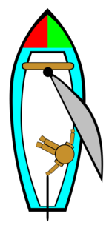

1. As shown in the diagram, Car 1 is moving to the right at an initial speed *u*. The car then impacts the rear end of Car 2, which is initially stationary. Both Car 1 and Car 2 have the same mass *m*. After the collision, both cars are effectively joined and move to the right at half of the initial speed of Car 1.

Determine if the collision was elastic or inelastic.

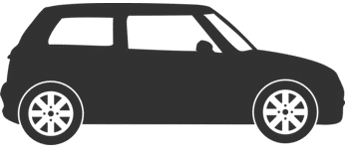

u

u = 0

Car 1

Car 2

1. At the end of the last Apollo 15 moon walk, Commander David Scott dropped a 1.32 kg geologic hammer and a 0.030 kg falcon feather from a height of 1.60 m above the surface of the moon. He observed that when the feather and the hammer were dropped simultaneously, they both impacted the surface of the moon at the same time. Explain this observation.
2. The figure below shows a water skier being pulled to the right by a speed boat. The water skier and the boat are travelling in a straight line and the water skier is directly behind the boat. The mass of the person is 80.0 kg and the frictional force between the water skier and the water is 100 N. *T* is the tension in the rope.The water skier has an initial speed of 12.8 m s-1 and is accelerated by the boat at 5.20 m s-2.

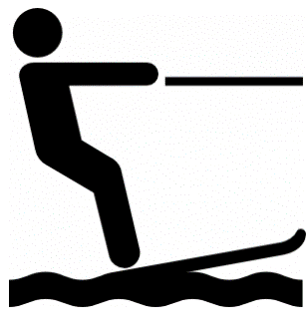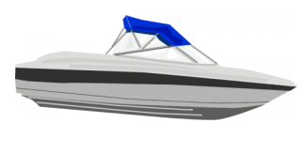

T

* 1. Calculate the time that it takes for the water skier to reach a final speed of 64.0 m s-1.
  2. Calculate the distance that the skier travels while being accelerated.
  3. Calculate the work done by the boat while pulling the water skier a distance of 3.00 km at a constant speed of 64.0 m s-1.
  4. Calculate the tension in the rope if the rope is horizontal and the water skier is accelerated at 5.20 m s-2.
  5. The angle of the ski rope is changed such that it now makes an angle of 15.0 º to the horizontal. Calculate the tension in the rope if the friction force is 100 N and the boat travels at a constant speed.

1. Horsepower (hp) is an old unit to measure power, the rate at which work is done. The diagram below shows that 1.00 hp is needed to lift a 75.0 kg mass 1.00 metre in 1.00 second.  
   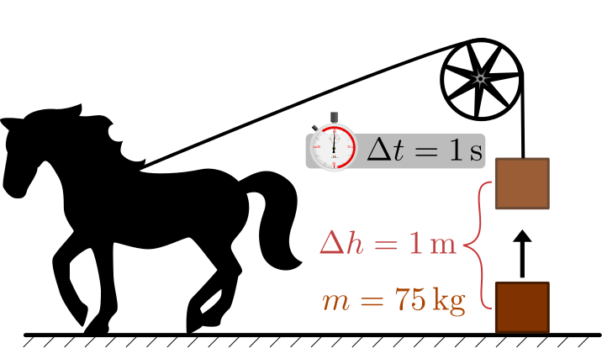  
   1. Show by calculation that 1.00 hp ≈ 735 W.
   2. If a 12.5 hp air conditioner is working for 2 minutes 15 seconds, calculate how much work has been done.
2. Jack drops a small rubber ball from a height of 1.50 m above flat ground. The mass of the ball is 0.120 kg. Air resistance can be neglected for each of the following questions.
   1. Which of the following statements correctly describes the applied forces as the ball impacts the ground? Circle the correct answer and provide an explanation below.
      1. The force that the ball applies to the ground is **greater than** the force that the ground applies to the ball.
      2. The force that the ball applies to the ground is **less than** the force that the ground applies to the ball.
      3. The force that the ball applies to the ground is **equal to** the force that the ground applies to the ball.

Explanation:

* 1. Calculate the velocity of the ball as it impacts the ground.
  2. The ball is dropped again from a different height and impacts the ground with a speed of 5.00 m s-1. If the collision that the ball makes with the ground is elastic and the impact time is 0.01 s, calculate the magnitude of the average force that the ball applies to the ground.
  3. A 46.0 g golf ball is dropped and impacts the ground with a velocity of 7.00 m s-1. The golf ball then rebounds to a height of 1.75 m above the ground. Calculate the efficiency of the impact.

1. A 0.10 kg hockey puck is at rest. A force of 20.0 N acts on it for 0.20 s, which sets it in motion. Over the next 2.00 s it encounters an average of 0.40 N frictional force. Calculate the puck’s final speed.
2. In a game of 10-pin bowling, a person bowls a 10.5 kg bowling ball so that it hits the last remaining 0.9 kg bowling pin at 2.4 m s-1 and continues after the collision at 2.1 m s-1.
   1. Calculate the speed of the pin immediately after the collision.
   2. Determine whether this was an elastic collision, showing all working.